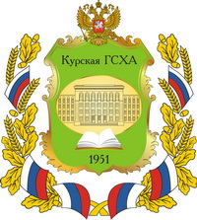
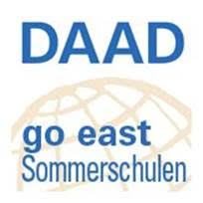
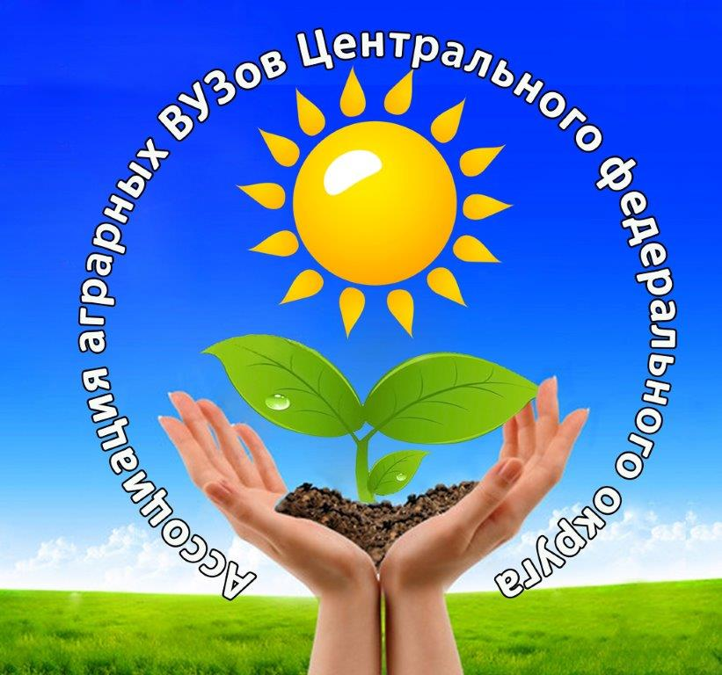
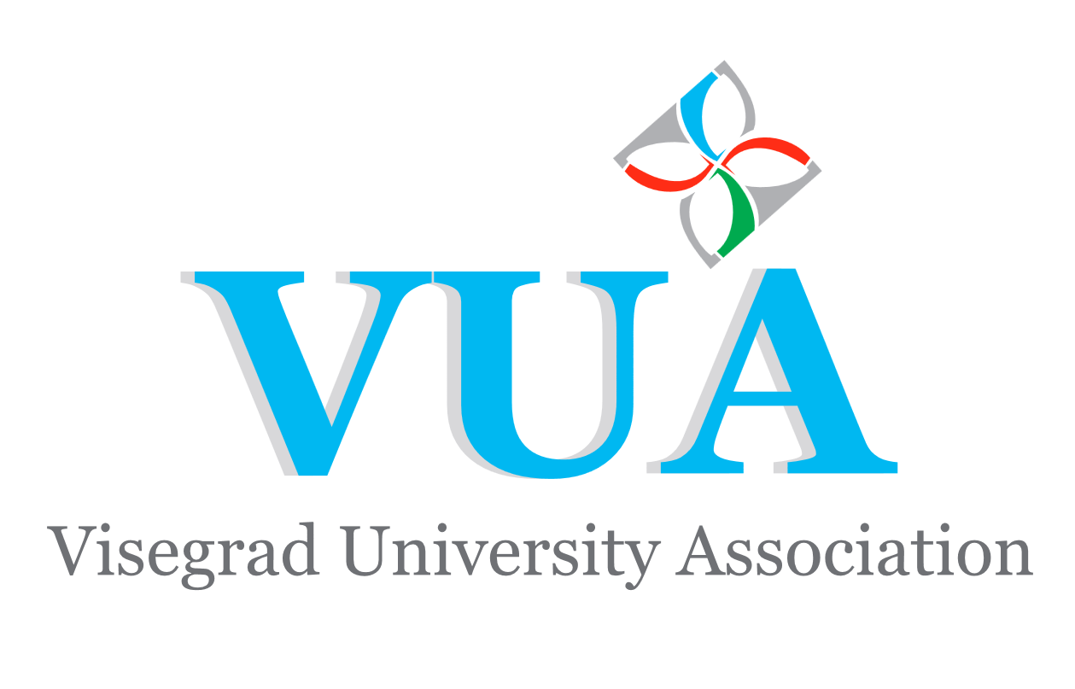
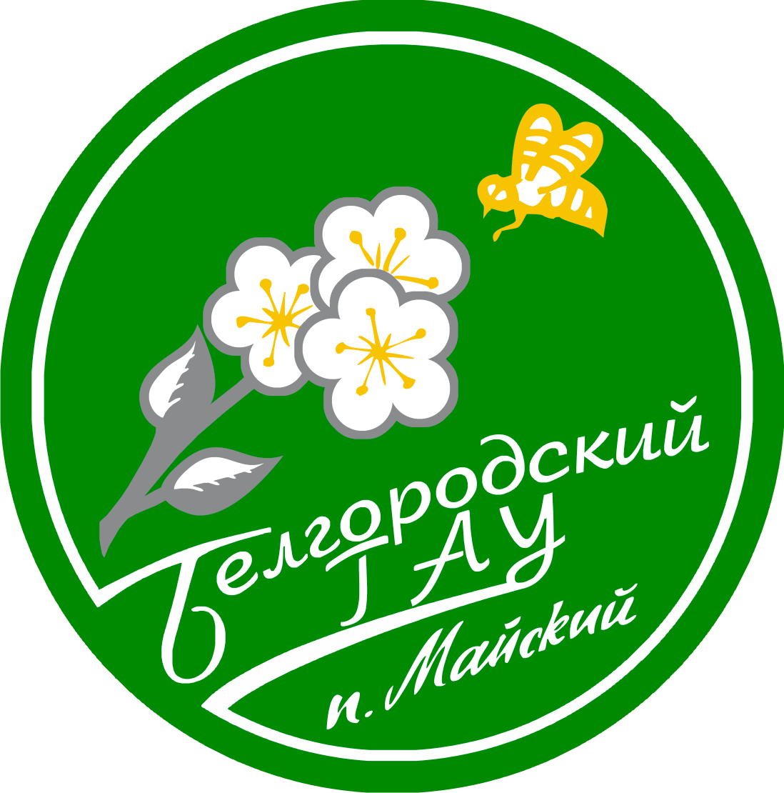

International Summer School
“AGRISUMMER IN BLACK SOIL REGIONS OF RUSSIA”
(Belgorod and Kursk regions)

PRELIMINARY PROGRAMME

Belgorod State Agricultural University
July, 29 - August 6, 2018
Time | Activity
30.07.2018 Arrival
17.00 | Arrival, accommodation, dinner
31.07.2018
Agricultural Production, education and science in Russia and Belgorod region
8.30 – 9.30 | Breakfast
10.00 – 10.30 | Opening Ceremony, Presentation of the University
10.30 – 13.00 | Excursion to the campus
13.00 – 14.00 | Lunch
14.00 – 15.30 | Presentation 1: Development of Agriculture in Russia and Belgorod region.
16.00 – 17.00 | Visit of the scientific and practical training center “Agrotekhnopark” (Horse-riding)
17.00 – 18.00 | Language practice (optional): “Easy Russian”
18.00 – 19.00 | Dinner
01.08.2018
Agricultural Production in Belgorod region
8.30 – 9.30 | Breakfast
9.45 – 11.15 | Presentation 2: Problems of Agriculture in Russia in the WTO and sanction conditions.
11.15 – 14.00 | Excursion to the Agirfarm “Kolkhos Gorina”
14.00 – 15.00 | Lunch
15.00 | Departure to the holiday campus
15.30 – 18.00 | Teambuilding course
18.00 – 22.00 | Picnic, dance party
02.08.2018
Agriculture in Belgorod region. Pork Production and Processing
8.30 – 9.30 | Breakfast
9.45 – 11.15 | Presentation 3: Development of Pork Production in Belgorod region
11.30 – 13.00 | Presentation 4: Meat Processing
13.00 – 14.00 | Lunch
14.00 – 14.45 | Transfer to Krapivinskiye Dvory
14.45 – 17.15 | Visit to the Slaughterhouse of the Pig Company AgroBelogorie
17.15 – 18.00 | Transfer to Mayskiy
18.00 – 19.00 | Dinner
19.00 – 20.00 | Language practice (optional): “Easy Russian”

03.08.2018
Agriculture in Belgorod region. Poultry Production and Processing
8.30 – 9.30 | Breakfast
9.45 – 11.15 | Presentation 5: Poultry Production in Belgorod Region
11.30– 13.00 | Transfer to Rakitnoye
13.00 – 14.00 | Lunch
14.00 – 16.30 | Visit of the BZRK-Belgrankorm Agricompany
16.30 – 18.00 | Transfer to Mayskiy
18.00 – 19.00 | Dinner
19.00 – 20.00 | Language practice (optional): “Easy Russian”
04.08.2018
Biogas production + Cultural trip
8.30 – 9.30 | Breakfast
9.30 – 11.00 | Presentation 6: Development of Biogas Production in Belgorod Region
11.00 | Departure
12.00 – 13.00 | Visit of the Biogas Station “Luchki” LLC “AltEnergo”
13.00 – 14.00 | Lunch
14.00 -18.00 | Departure to the village Kostroma  Excursion to the Open Space Museum “Klyuchi” (Voyage)
18.00 – 19.00 | Dinner
19.00 | Departure to Belgorod
05.08.2018
Cultural trip
8.30 – 9.30 | Breakfast
9.30 -10.00 | Language practice (optional): “Easy Russian”
10.00 - 13.00 | Excursion to the city
13.00 – 14.00 | Lunch
14.00 – 17.00 | Picnic Park visit
17.00 – 18.00 | Dinner
18.00 – 23.00 | Visiting of the Celebration Events of the Day of the City (Salute)
06.08.2018
Closing Ceremony, Departure
8.30 – 9.30 | Breakfast
9.30 -10.00 | Language practice (optional): “Easy Russian”
10.00-11.00 | Closing Ceremony
11.00-12.00 | Free time in Belgorod
12.00 | Departure to Kursk
Kursk State Agrarian University
August 06-12, 2018
Time | Activity
06.08.2018 Arrival
13.30 | Arrival, accommodation, lunch, free time
18.00-19.00 | Dinner
19.00 – 21.00 | Excursion to the city
07.08.2018
Agricultural education and science in Kursk region
8.30 – 9.30 | Breakfast
9.45 – 10.30 | Presentation 1:Presentation of the Kursk State Agricultural Academy
10.30 – 13.00 | Excursion to the Academy campus
13.00 – 14.00 | Lunch
14.00 – 15.30 | Presentation 2. The main Activities and Experience of the LLC “Seim-Agro”
15.30 – 17.00 | Visit to LLC “Seim-Agro” (Department of Kursk State Agricultural Academy)
17.00 – 18.00 | Language practice (optional): “Easy Russian”
18.00 – 19.00 | Dinner
08.08.2018
Development and Main Agricultural Branches of Kursk region
8.30 – 9.30 | Breakfast
9.45 – 11.15 | Presentation 3: Agriculture in Kursk region.
11.30 – 13.00 | Presentation 4: Travelling to the Past, Present and Future of Kursk.
13.00– 14.00 | Lunch
14.00– 18.00 | Excursion to the Central-Chernozem State Biosphere Nature Reserve named after Alekhin (the world as it was without human interference)
18.00 – 19.00 | Dinner
19.00 – 20.00 | Language practice (optional): “Easy Russian”
09.08.2018
Development of Agricultural Processing Industry in Kursk region
8.30 – 9.30 | Breakfast
9.45-11.15 | Presentation 5.Development of Agricultural Processing Industry in Kursk region.
11.30-13.00 | Presentation 6: Bakery and Pastry Products, Production, Culture and Customer Service
13.00 – 14.00 | Lunch
14.00 – 16.00 | Visit to LLC “Kurskhleb”
16.00 – 17.00 | Meeting with students
17.00 – 18.00 | Language practice (optional): “Easy Russian”
18.00 – 19.00 | Dinner
10.08.2018
Chocolate Production in Kursk region
8.30 – 9.30 | Breakfast
9.45 – 11.15 | Presentation 7: Modern Confectionery Plant LLC “KONTI-RUS”.
11.30 – 14.00 | Visit to the Confectionery Plant LLC “KONTI-RUS”
14.00 – 15.00 | Lunch
15.00 – 18.00 | Excursion to the City
18.00 – 19.00 | Dinner
19.00 – 20.00 | Language practice (optional): “Easy Russian”
11.08.2018
Dairy Production in Russia and Kursk region. Small and Medium Agribusiness in Kursk region
8.30 – 9.30 | Breakfast
9.45 – 11.15 | Presentation 8. Dairy Production in Russia and Kursk region
11.30 – 13.00 | Presentation 9: Small and Medium Agribusiness as a Major Contributors to the Development of the Regional Economy
13.00 – 14.00 | Lunch
14.00 – 18.00 | Visit to the Private Farm in Medvenka District
18.00 – 22.00 | Dinner, games and dance party
12.08.2018
Cultural trip
8.30 – 9.30 | Breakfast
9.30 – 10.00 | Closing Ceremony
10.00 – 14.00 | Departure to «Korennaya Pustyn» Monastery (The Pearl of Russian Orthodoxy)
14.00 – 15.00 | Lunch
15.00 – 18.00 | Free time in Kursk
18.00 – 19.00 | Dinner
23.00 | Departure to Moscow (night train)

